Sales data Analysis-SQL queries
Queries

- Columns’ Name
Transaction ID
Date
Country
Product ID
Product Name
Category
Price Per Unit
Quantity Purchased
Cost Price
Discount Applied
Payment Method
Customer Age Group
Customer Gender
Store Location
Sales Representative

- Merging the 6 datasets
CREATE TABLE public."Sales Analysis" as
select * from public."Sales Canada"
UNION ALL
SELECT * FROM public."Sales China"
Union all
SELECT * FROM public."Sales India"
Union all
SELECT * FROM public."Sales Nigeria"
Union all
SELECT * FROM public."Sales UK"
Union all
SELECT * FROM public."Sales US"
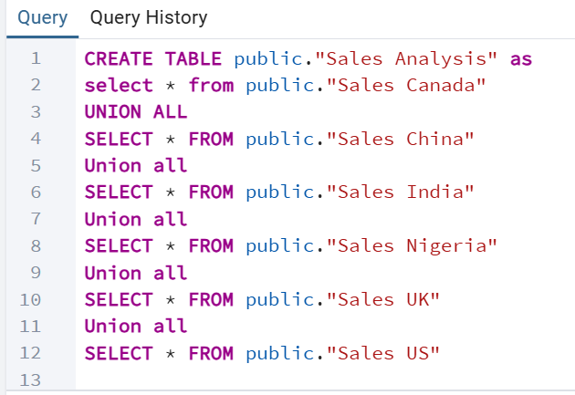
- Checking for missing values
select *
from public."Sales Analysis"
where
"Country" is null
or "Price Per Unit" is null
or "Quantity Purchased" is null
or "Cost Price" is null
or "Discount Applied" is null;
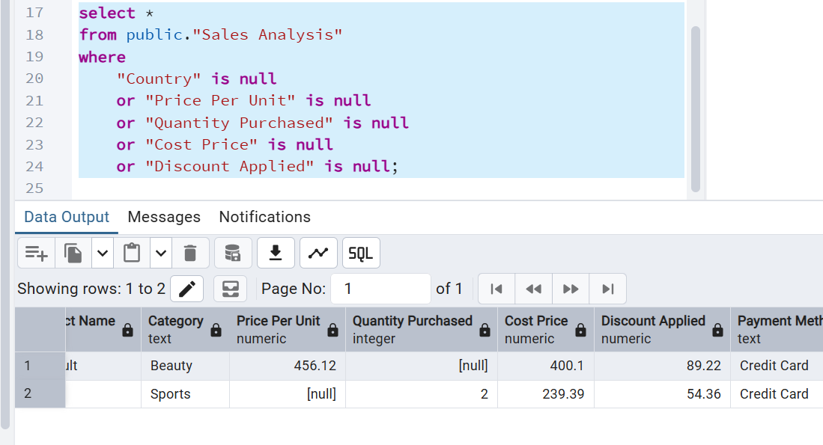

- Updating “Quantity Purchased”
update public."Sales Analysis"
set "Quantity Purchased" = 3
where "Transaction ID" = '00a30472-89a0-4688-9d33-67ea8ccf7aea'

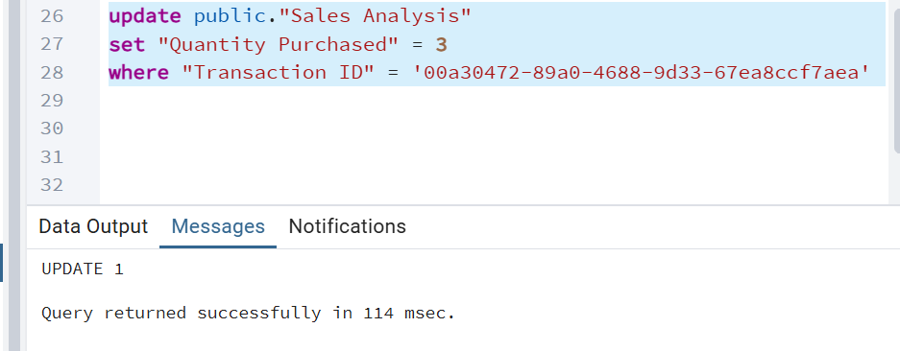

- Updating “Price Per Unit”
update public."Sales Analysis"
set "Price Per Unit" = (
SELECT AVG("Price Per Unit")
from public."Sales Data"
where "Price Per Unit" is not null
)
where "Transaction ID" = '001898f7-b696-4356-91dc-8f2b73d09c63';

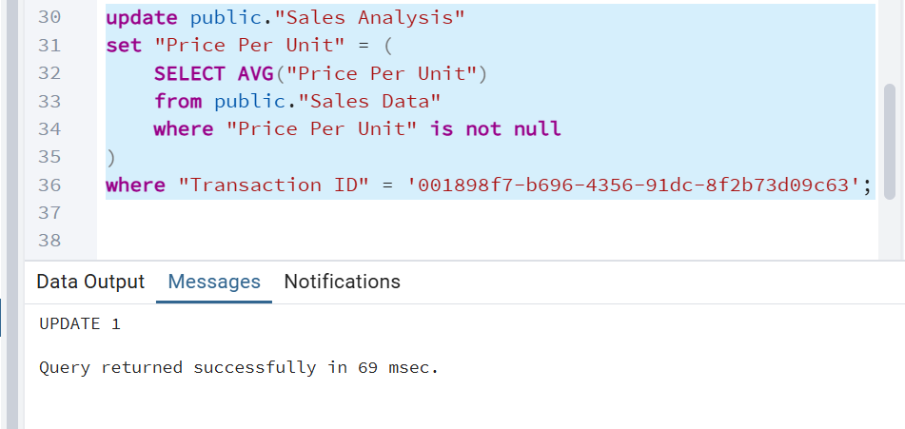
- Checking for duplicate values
select "Transaction ID", Count(*)
from public."Sales Analysis"
group by "Transaction ID"
having count(*)>1;
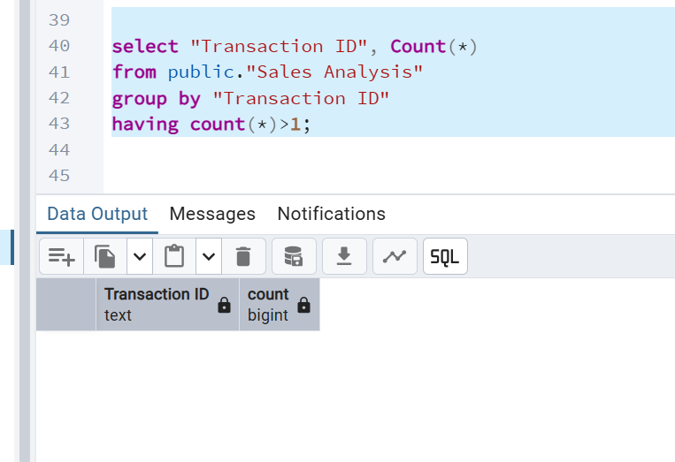

- Adding “Total Amount” column
Alter table public."Sales Analysis" add
column"Total Amount" Numeric(10,2);

update public."Sales Analysis"
set "Total Amount"=("Price Per Unit" * "Quantity Purchased") - "Discount Applied";

- Adding “Profit” column
alter table public."Sales Analysis" add
column "Profit" Numeric(10,2);

update public."Analysis "
set "Profit"="Total Amount" - ("Cost Price" + "Quantity Purchased");

- Sales Revenue & Profit by Country (Combined Query)
SELECT
"Country",
SUM("Total Amount") AS "Total Revenue",
SUM("Profit") AS "Total Profit"
FROM public."Sales Analysis"
WHERE "Date" BETWEEN '2025-02-10' AND '2025-02-14'
GROUP BY "Country"
ORDER BY "Total Revenue" DESC;
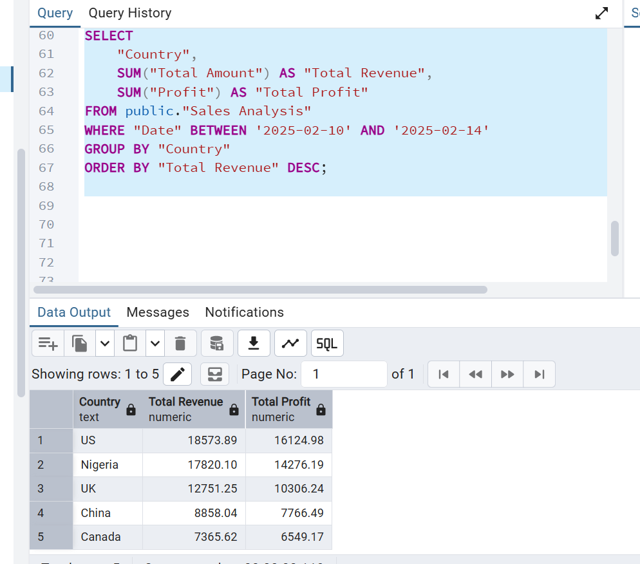
- Top 5 Best-Selling Products (During the Period)
SELECT
"Product Name",
SUM("Quantity Purchased") AS "Total Units Sold"
FROM public."Sales Analysis"
WHERE "Date" BETWEEN '2025-02-10' AND '2025-02-14'
GROUP BY "Product Name"
ORDER BY "Total Units Sold" DESC
LIMIT 5;
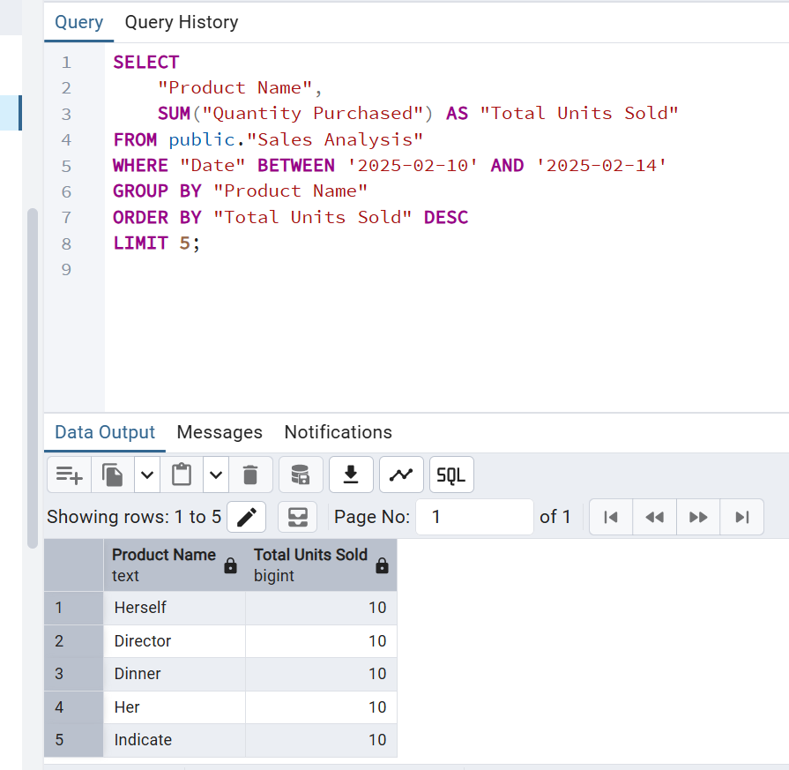

- Best Sales Representatives (During the Period)
SELECT
"Sales Representative",
SUM("Total Amount") AS "Total Sales"
FROM public."Sales Analysis"
WHERE "Date" BETWEEN '2025-02-10' AND '2025-02-14'
GROUP BY "Sales Representative"
ORDER BY "Total Sales" DESC
LIMIT 5;
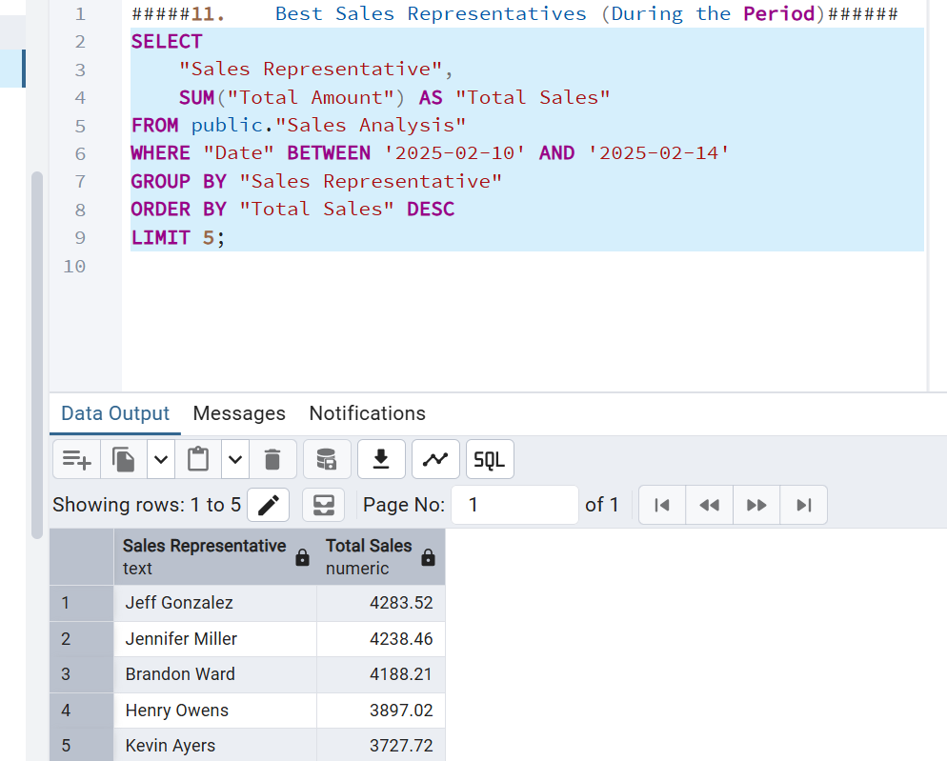
- Which store locations generated the highest sales?
SELECT
"Store Location",
SUM("Total Amount") AS "Total Sales",
SUM("Profit") AS "Total Profit"
FROM public."Sales Analysis"
WHERE "Date" BETWEEN '2025-02-10' AND '2025-02-14'
GROUP BY "Store Location"
ORDER BY "Total Sales" DESC
limit 5;
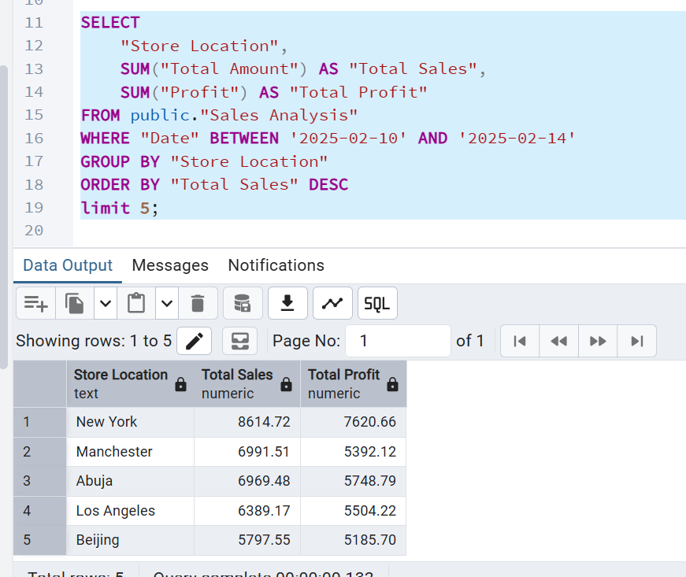
- What are the key sales and profit insights for the selected period?
SELECT
MIN("Total Amount") AS "Min Sales Value",
MAX("Total Amount") AS "Max Sales Value",
AVG("Total Amount") AS "Avg Sales Value",
SUM("Total Amount") AS "Total Sales Value",
MIN("Profit") AS "Min Profit",
MAX("Profit") AS "Max Profit",
AVG("Profit") AS "Avg Profit",
SUM("Profit") AS "Total Profit"
FROM public."Sales Analysis"
WHERE "Date" BETWEEN '2025-02-10' AND '2025-02-14';

